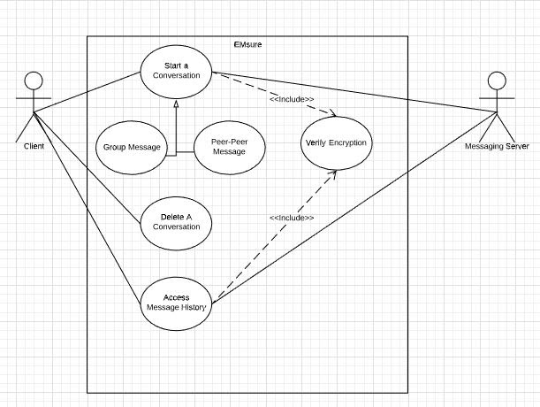

Use Cases

1. Send Message
   1. Peer to Peer
   2. Group
2. Delete Conversation – Locally remove a conversation from memory
3. Access Message History – View all ongoing conversations